- Do you agree that nowadays “without a mobile phone you don’t exist”?

I agree. But only if it mean that you don’t exist for other people. Without mobile phone you can’t get a credit card at the bank, can’t register in most of the web-services, can’t communicate with other people if you’re away from your PC or landline phone. I think you can live like this, but it would be inconvenient for you and people that want to stay in touch with you.

- How dependent is your work or social life on a having a mobile phone or smartphone? Would your arrangements break down if you didn’t have one?

In terms of communication I can switch from smartphone to laptop without any trouble, but only if I stay home. Without phone outside of my home I would be non-existent for people that are not prepared for this. So my social life is slightly dependable on phone, and so is my work because you can’t predict when and how you manager or boss want to get in touch with you.

- Do you consider yourself addicted to your phone? How often do you check it for messages? Would you consider switching to a dumb phone, one that has no Internet and can only receive calls and text messages?

I don’t think I’m addicted to my phone. I check messages only if I expect them, and for most part I check them on my laptop. I would consider switching to a no-internet phone only if my life become very stable and predictable, so that I would not be in need to be prepared to communicate with anyone at any moment.

- Which of these two pictures is closer to the thinking that goes on in your head? Or perhaps you experience both? In either case, explain.
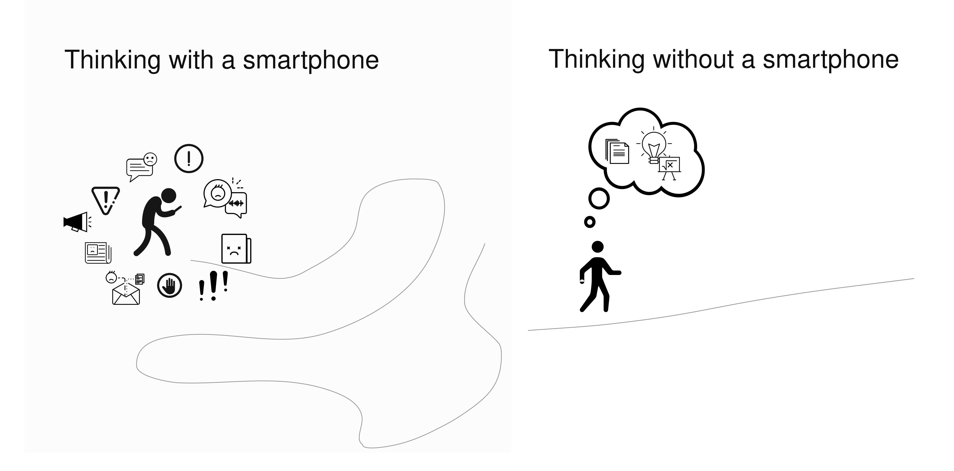
I think I simplified my use of smartphone well enough so that my thinking look more like on second picture even when I use it. I don’t like to be bothered with dozens of notifications from dozen apps, so I configured my phone in a way that it acts almost as a dumb-phone but with messages from Telegram and etc. instead of SMS.

- “Social media tools are meant to be addictive. They are designed to fragment your attention as much as possible throughout your waking hours…and this can permanently reduce your ability to concentrate.” Is this a problem for you?

I think it a problem for me, but I’m trying to manage it. Mainly by distancing myself from unnecessary use of social media. I don’t even use Instagram*, only Telegram and VK for messaging.

*Instagram is a project of Meta Platforms Inc., whose activities are prohibited in Russia

- “Though smartphones can open up whole new vistas of knowledge, they can take people away from appreciating the world around them.” Do you agree?

I agree, but on the other hand, they begin to appreciate world outside of their physical location. And it is bad if you’re living only inside your phone.

- Is it a good idea to outsource part of our memory to an external device, to our phones? Does it enable us to squeeze more out of life by letting us focus on other things? Or will our memory simply get worse, because we have stopped using it?

It is a good idea if you use external devices as a backup for your memory, not as replacement. Smartphone allow us to do more, faster, anywhere, so we can solve our problems optimally. Maybe our memory will shrink, but with new technologies maybe it doesn’t matter at all and we wouldn’t even notice.

